Winter 2026

Github : https://github.com/Seulgilet/PRJ566NBB_2261_Group6
SmartMatch – Student Team Project Matching Platform

Software Requirements Specification

Smart Match | PRJ566 NBB - Group 6
Seulgi Lee, Moe Thet Paing
Yahya Osman, Jackson Pedvis, Rohit Sivakumar

Executive Summary

Background

Description

Company Value Add

End-User Value Add

Scope

What is Included

What is Not Included

Justification

Table of Contents
Background 1
Description 1
Company Value Add 1
End-User Value Add 1
Scope 1
What is Included 1
What is Not Included 1
Justification 1
1.1 Document Authors 4
1.2 Document Revision History 4
1.3 Document Purpose 4
1.4 Audience 5
1.5 Group Agreement 5
Team: 5
Project Title 5
Project Time Frame: 5
Team Members: 6
Team Leadership: 6
Team Functions/Roles: 6
Team Meetings 6
Team Problems 6
Team Commitment 6
2.1 Project Proposal 7
2.1.1 Project Background 7
2.1.2 Problem Statement 9
2.1.3 Product Vision 10
2.2 Stakeholders and Users 11
Stakeholder & User Avatars 12
Avatar 1 – Student User 12
Avatar 2 – Course Instructor 12
Avatar 3 – System Administrator 12
Avatar 4 – Project Development Team 12
2.3 Project Scope 13
2.4 System Risks 15
Probability / Impact Scale 15
Probability / Impact Matrix 15
Risk Summary 17
2.5 Operating Environment 18
Hardware / Devices Supported 18
Operating System 18
Software Dependencies 18
Internet Connection 19
2.6 Functional Requirements 20
2.7 Nonfunctional Requirements 20
2.8 UI/UX Interface Mock-ups 20
3.1 Data Flow Diagrams 21
3.2 Iser Stories and related Use Case Scenarios 21
3.3 Activity Diagrams 21
3.4 Business Rules 21
6.1 Work Breakdown Structure 22
6.2 Milestones & Acceptance Criteria 22

Section 1

1.1 Document Authors
- Seulgi Lee
- Moe Thet Paing
- Yahya Osman
- Jackson Pedvis
- Rohit Sivakumar

1.2 Document Revision History
WEEK | DATE | Revisions
1 | Jan 25, 2026 | - Section 1  - Section 2.1
2 | Feb 1, 2026 | - Section 2.2, 2.3, 2.4, 2.5
3 | Feb 8, 2026 | - Section 2.6, 2,7
4 | March 1,2026 | - Section 2.8
5 | March 1 , 2026 | - OverAll revision
6
7
8
9
11
12
13
14

1.3 Document Purpose
The purpose of this Software Requirements Specification (SRS) document is to formally define and document the functional and non-functional requirements of the SmartMatch – Student Team Project Matching Platform. This document serves as the primary reference for all stakeholders by clearly specifying what the system is expected to accomplish, the boundaries of the system, and the conditions under which it must operate.This SRS establishes a common understanding between the project team, faculty, and other stakeholders regarding system objectives, scope, and constraints before the commencement of system design and implementation activities. By capturing requirements in a structured and standardized format, the document aims to minimize ambiguity, reduce the risk of misinterpretation, and prevent scope creep throughout the project lifecycle.

1.4 Audience
This Software Requirements Specification is intended for a diverse audience involved in or affected by the SmartMatch project.
The primary audience includes:
- Project Team Members, who will use this document to guide analysis, design, development, and testing activities in alignment with defined requirements.
- Faculty and Course Evaluators, who will review the document to assess academic rigor, requirement completeness, and adherence to professional software engineering standards.
- Project Stakeholders and Client Representatives, who will validate that the documented requirements accurately reflect the intended problem domain and proposed solution.
A secondary audience may include future developers or maintainers who require an understanding of system requirements and rationale to support system enhancement or maintenance. The document is written to balance technical clarity with accessibility, ensuring it remains understandable to both technical and non-technical readers.

1.5 Group Agreement

Team:
Project Planning and Management Group #6

Project Title
SmartMatch - Student Team Project Matching Platform

Project Time Frame:
Approximately 6 month time frame
Winter 2026 - Summer 2026

Team Members:
Seulgi Lee
Yahya Osma
Moe Thet Pain
Jackson Pedvis
Rohit Sivakumar

Team Leadership:
Project Manager: Seulgi Lee
Mainly responsible for project coordination, timeline management, final tests and project refinement.

Team Functions/Roles:
Seulgi Lee : Project Manager/ frontend development
Yahya Osman : Documentation/ Frontend development/ Business case Development
Moe Thet Paing: Backend Development/ UI/UX Development
Jackson Pedvis: Documentation/Quality Assurance / Team coordination
Rohit Sivakumar: Algorithm & Business Logic Designer

Team Meetings
Meeting #1: In person, Mondays 13:30
Meeting #2: Online, Thursdays 11:40

Team Problems
Some potential problems the team might face:
- Schedule conflicts
- Workload balance
- Technical issues
- Communication issues

Team Commitment
The undersigned members agree to work together on the project until the end of the PRJ666 next Semester. They recognize that as a team and individually they are equally responsible for the quality of all deliverables.

Name | Date | Signature
Seulgi Lee | 25/01/2026 | SL
Yahya Osman | 25/01/2026 | YO
Moe Thet Pain | 25/01/2026 | MP
Jackson Pedvis | 02/02/2026 | JP
Rohit Sivakumar | 08/02/2026 | RS

Section 2

2.1 Project Proposal

2.1.1 Project Background

Market Overview
- Many programs (computer science, engineering, business) rely on graded group work as a core assessment method.
- Research indicates that well-structured team learning can improve educational outcomes compared to individual learning.
- Growth of hybrid and online learning environments has increased reliance on digital coordination and collaboration tools.
The global Learning Management System (LMS) market is valued in the tens of billions of USD and is projected to grow steadily through the next decade.Institutions continue investing in digital learning infrastructure that supports course delivery and student management.

Current Team Formation Methods
- Student self-selection
- Manual instructor assignment
- Random assignment via Learning Management Systems (LMS)
Traditional student grouping methods frequently struggle to balance efficiency with equity: self-selection often fosters bias, manual assignment fails to scale for large cohorts, and random assignment ignores essential variables like skill sets and schedules. This gap is further widened by current LMS platforms, which provide basic automation but lack the sophisticated, multi-criteria optimization and transparent logic necessary to create truly balanced and effective teams.

Competitor Landscape
Overview | Capabilities | Limitations
Learning Management Systems (LMS) | - Provide group creation and management tools  - Support manual or random student assignment  - Integrated into existing academic workflows | - Do not optimize team composition using multiple student attributes  - Limited support for skill-based or role-based matching
Cross-Domain Grouping and Matching Systems | - Use constraint-based matching with availability and preferences  - Demonstrate scalability of multi-criteria assignment approaches | - Not designed for academic assessment contexts  - Do not address grading fairness or educational learning outcomes  - Lack support for student-specific roles or project skills
Post-Formation Team Management Tools | - Support peer evaluation and team performance monitoring  - Enable instructor intervention after teams are formed | - Do not address issues arising from poor initial team formation  - Focus on corrective measures rather than prevention

Market Gap
- Existing solutions focus on administrative convenience, not team quality optimization.
- There is no lightweight system that:
- Uses structured student profile data
- Applies multi-factor matching (skills, availability, role preference)
- Provides explainable team formation outcomes

2.1.2 Problem Statement

The problem of | In many universities and colleges, team projects are an essential part of coursework. However, when forming teams, institutions still rely on random assignment or student self-selection methods, resulting in groups being formed without any meaningful information about group members. In these cases, students are assigned to teams without knowing their teammates’ skills, availability, work styles, or expectations, which creates uncertainty at the start of projects and makes effective collaboration difficult from the beginning.
Affects | This problem affects students, professors, and educational institutions alike. Students frequently encounter unfair workload distribution, lack of leadership, scheduling conflicts, and interpersonal issues. Professors and institutions must invest additional time and effort in managing team conflicts, addressing complaints, and ensuring fair evaluation.
The impact of which is | As a result, teams are unable to work effectively from the beginning of the project. Collaboration becomes inefficient, time and effort are wasted, learning outcomes diminish, and the operational burden on institutions increases.
A successful solution would be | An ideal solution should provide a team formation process that considers individual characteristics and circumstances, such as students’ skills, availability, work styles, and role preferences, along with a transparent team formation process, promotion of balanced participation, and reduction of early-stage project conflicts. Through this approach, it should improve students’ learning experience and enable institutions to manage team-based courses more effectively.

2.1.3 Product Vision

For (target customer) | For educational institutions such as universities and colleges
Who | Face challenges caused by random or informal team formation methods, including team conflicts, unbalanced workload distribution, reduced learning outcomes, and increased administrative effort related to managing team-based projects
The SmartMatch | SmartMatch is a B2B web-based team matching platform designed to support the structured formation of student teams for academic, course-based team projects by using student-provided data rather than random or manual assignment methods
That | Considers individual skills, availability, role preferences, and collaboration styles to form balanced teams, provides transparency in the team formation process, reduces conflicts at the early stages of projects, and improves student participation and overall learning experience,
Unlike | Unlike manual, random, or instructor-driven team assignment methods, or basic group creation features commonly found in learning management systems
Our product | SmartMatch offers clear matching criteria and understandable team composition outcomes, enabling institutions to manage team-based courses through consistent, data-driven team formation processes, fair workload distribution based on student attributes, and reduced administrative time spent on manual team assignment and conflict management.

2.2 Stakeholders and Users
Stake Holder Overview

SmartMatch involves multiple stakeholder groups who interact with, are impacted by, or influence the system. These stakeholders have different goals, responsibilities, and levels of involvement. Identifying them helps ensure that system requirements align with real-world academic and operational needs.
Can be segmented into two groups:
- Internal stakeholders are directly involved in building, operating, or managing SmartMatch.
- External stakeholders use, are affected by, or influence outcomes, but do not build or maintain the system.

Internal StakeHolders
StakeHolder | Role | Interest
Project Development Team | Designs and builds the system | Clear requirements, feasible scope
System Administrator | Maintains system availability | Security, uptime, data integrity
Academic Institution | Host the system | Policy compliance, consistency

External Stakeholder
StakeHolder | Role | Interest
Students | Receive team assignments | Fairness, workload balance
Course Instructors | Configure and approve teams | Transparency, reduced conflict
Teaching Assistants | Support instructors and students | Visibility , issue monitoring

Stakeholder & User Avatars

This represents typical stakeholders, not specific individuals.

Avatar 1 – Student User
- Role: Undergraduate student in team-based course
- Goals: Fair teams, predictable workload
- Concerns: Free-riders, schedule conflicts
- Interaction: Profile creation, team review

Avatar 2 – Course Instructor
- Role: Faculty member managing group projects
- Goals: Balanced teams, fewer disputes
- Concerns: Transparency, grading fairness
- Interaction: Set criteria, review assignments

Avatar 3 – System Administrator
- Role: IT staff maintaining platform
- Goals: Stability, data protection
- Concerns: Security, access control
- Interaction: System monitoring

Avatar 4 – Project Development Team
- Role: Student developers
- Goals: Meet SRS requirements
- Concerns: Scope creep, ambiguity
- Interaction: Implement features

2.3 Project Scope
This section explains what the smartMatch system is responsible for, what it does and what it doesn't. Defining the project scope helps keep the project focused and avoids adding features that are outside the original goals.
What the system will do:
SmartMatch is designed to help make a fair and balanced student teams for course based group projects.
The system modules:
- User Authentication modules:
  - Manages and processes user authentication, login credentials, and role-based access control to ensure that students and instructors can securely access the appropriate features and functionalities of the system
- Student profile management:
  - Enables students to create comprehensive personal profiles that include detailed information about their technical skills, subject matter expertise, weekly availability and scheduling preferences, preferred team roles and responsibilities, and individual working style preferences
- Instructor module:
  - Enables instructors to define and configure team formation rules, including parameters such as team size, matching constraints, and grouping criteria
- Algorithm-Based Team Matching module (Core):
  - Automatically generates balanced and fair project teams by analyzing student data and instructor-defined rules. This module creates optimal team combinations by considering students' skills, preferences, and availability.
- Web Interface Module:
  - Provides a responsive, browser-based interface that ensures accessibility across a wide range of devices, including desktop computers, laptops, tablets, and smartphones, allowing users to interact with the system seamlessly regardless of their device choice.

What the system will not do:
- Project Management Component
  - It does not include project execution and management features such as task list management, deadline management, and progress tracking after teams are formed.
- Communication Component
  - It does not provide built-in communication tools such as chat, messaging, video calls, or discussion boards.
- Assessment and Grading Component
  - Grading, scoring, and performance evaluation features for instructors are not supported by the system.
- Learning Management System Integration Component
  - Integration features with external learning management systems such as Moodle or Blackboard are not included in the current project scope.
Scope summery:
The SmartMatch system will maintain a singular and dedicated focus exclusively on the process of creating, forming, and organizing student teams in a manner that ensures fairness, balance, and equitable distribution of skills and resources, specifically for the purpose of course-based group projects within academic settings.

2.4 System Risks
This section describes potential problems that could happen while building, launching, and using the SmartMatch system. Each problem is reviewed based on how likely it is to happen (Probability) and how serious it would be (Impact). SmartMatch is an academic project that helps form teams in settings where this was usually done by hand. Problems are grouped into five types: Market, Financial, Technology, People, and Structural/Process. For each problem, we suggest ways to reduce or prevent it.

Probability / Impact Scale
- Low: Not likely to happen or won't cause much harm
- Medium: Somewhat likely to happen or could cause some harm
- High: Very likely to happen or could cause serious harm

Probability / Impact Matrix
Probability | High |  | Risk 8  Risk 2  Risk 6 | Risk 3
Probability | Medium | Risk 4 | Risk 9 | Risk 5  Risk 7
Probability | Low |  | Risk 1
 |  | Low | Medium | High
 |  | Impact

Risk No | Type | Risk Category | Risk Description | Probability | Impact | Mitigation Strategy
Risk 1 | General | Market Risk | Schools and universities that have always formed teams by hand may not see why they need a new system | Medium | Low | Explain the system's advantages clearly, such as less work for administrators and better team results than doing it manually.
Risk 2 | Specific | Market Risk | Students may not want to enter their profile details or may enter very little information, which could result in low system usage | High | Medium | Only ask students for the most important information and give them simple instructions to make it easier for them to participate.
Risk 3 | General | Financial Risk | The academic nature of the project limits the budget available for system development and operation | High | Medium | Use open-source technologies and free development tools, and focus development efforts on core MVP functionality.
Risk 4 | General | Financial Risk | Unexpected operational costs may occur during deployment or testing environment setup | Low | Medium | SmartMatch is an academic project with limited scope and controlled usage. It operates only during specific courses or project periods. Costs are minimized by limiting users and operation duration.
Risk 5 | Specific | Technology Risk | The matching rules may not work perfectly in every situation | Medium | High | Begin with basic matching rules that are easy to understand, then make them better step by step based on what you learn from testing.
Risk 6 | Specific | Technology Risk | If students give wrong or incomplete information, the team matching may not work well | High | Medium | Use input validation, define required fields, and restrict data formats to ensure data consistency.
Risk 7 | Specific | Technology Risk | Not enough students may be available to meet the team requirements, making it hard to form teams properly | Medium | High | Set up basic matching rules that work when there isn't enough data. Allow the system to be more flexible or let someone make changes by hand if needed.
Risk 8 | General | People Risk | Team members may miss work on the project because of their classes or personal reasons | High | Medium | Make realistic schedules and check progress regularly to handle schedule changes.
Risk 9 | Specific | Structural / Process Risk | Transitioning from manual to system-based team formation may make it hard to know who is responsible when problems happen with teams | Medium | Medium | Clearly define the system's role and limitations. Document operational guidelines and responsibility boundaries.

Risk Summary
The SmartMatch project has two main challenges. First, we need to switch from forming teams by hand to using an automated system. Second, we need to make sure the matching works well when students provide good information. Since this is a academic project used in specific classes, we can solve these problems by communicating clearly, setting clear system limits, and making improvements step by step.

2.5 Operating Environment
This section describes the environment in which the system is expected to operate.

Hardware / Devices Supported
SmartMatch is a web-based system designed to run on standard user devices without requiring specialized hardware.
The system supports the following devices:
- Desktop and laptop computers
- Tablet devices
- Smartphones (via a responsive web interface)
Users access the system through a web browser, and no high-performance hardware is required.

Operating System
SmartMatch is operating system independent. Since the system runs in a web browser, it can be accessed on any operating system that supports modern web browsers, including:
- Windows
- macOS
- Linux
- iOS
- Android
No operating system–specific installation is required.

Software Dependencies
The system requires a modern web browser to function properly. Supported browsers include, but are not limited to:
- Google Chrome
- Mozilla Firefox
- Microsoft Edge
- Apple Safari
The server needs a basic web setup and a database to run the system.
Users don't need to install anything except a web browser.

Internet Connection
You need an internet connection to use SmartMatch.
You must be online to:
- Log in to your account
- Create or update your profile
- Request team matches
- See your team assignments and match details
You cannot use the system without internet.

2.6 Functional Requirements

Overview
This section defines the functional requirements of the SmartMatch system.
Functional requirements describe what the system must do, including system behaviors, features, and user interactions. These requirements are derived from stakeholder analysis and user story interviews conducted with potential end users.

2.6.1 User Story Interviews

User Persona Avatars

Student | A user seeking compatible teammates for academic projects
Instructor & Lecturers | A faculty member managing courses and approving teams
System Administrator | System Config and Management

Interview Detail
Type : Oral Interview
Participants : post-secondary students working on group-based assignments
Objective: Identify pain points in forming fair and effective student teams

Interview Summarization

Key Problems Identified
- Unequal workload distribution
- Skill mismatch among teammates
- Last-minute team formation
- Lack of accountability
User Stories
Student User Stories

Id | User Story
1 | As a student, I want to enter my skills and strengths so that I can be matched with compatible teammates.
2 | As a student, I want to specify my availability so that team members have aligned schedules.
3 | As a student, I want to rate past team experiences so that future matches improve.

Instructor User Stories

Id | User Story
1 | As an instructor, I want to set team formation criteria so that teams align with learning objectives.
2 | As an instructor, I want to view team composition reports so that I can monitor fairness.

2.6.2 Core Functionalities

Id | User Story
CFR - 1 | The system shall allow students to create and manage user profiles.
CFR - 2 | The system shall collect student skill data and availability preferences.
CFR - 3 | The system shall generate team recommendations based on compatibility rules.
CFR - 4 | The system shall allow students to accept or reject team recommendations.
CFR - 5 | The system shall allow instructors to configure team size and matching criteria.
CFR - 6 | Data base for future analysis and report.

2.7 Nonfunctional Requirements

Overview
Nonfunctional requirements define how the system performs, focusing on quality attributes such as performance, security, usability, and reliability.

Usability Requirements:
- The system will provide a clear and easy to stir user interface for all users
- The system will be accessible through web browsers without requiring any software installation
- The system will have responsive design for all kind of devices (Desktops, phones, tablets)
Performance Requirements:
- The system will generate team matching results within a reasonable time according to class and group sizes
- The system will support multiple access by different users without noticeable performance issues
Security Requirements:
- The system will protect user data from unauthorized access
- User authentication will be stored in cryptic form for protection

Reliability Requirements:
- The system will handle invalid inputs
- The system will recover from system errors
- The system will allow profile updates and team generation while maintaining data consistency
Compatibility Requirements:
- The system will be compatible with different web browsers (Chrome, FireFox, Safari )
- The system will not be dependant on an operating system
Maintainability Requirements:
- The system will support future improvements
- The system code base will follow standard developments practices

2.8 UI/UX Interface Mock-ups

This section presents wireframe mock-ups for all core screens of the SmartMatch system, organized by user role and workflow. Each mock-up corresponds to a Business Rule (BR) and Use Case (UC) defined in Sections 2.6, 3.2, and 3.4. Screens are numbered as UI 2.7.X to align with the Business Rules table. Wireframes follow a consistent visual language: navy navigation bars, card-based content areas, and a blue-and-white palette reflecting the SmartMatch brand identity.
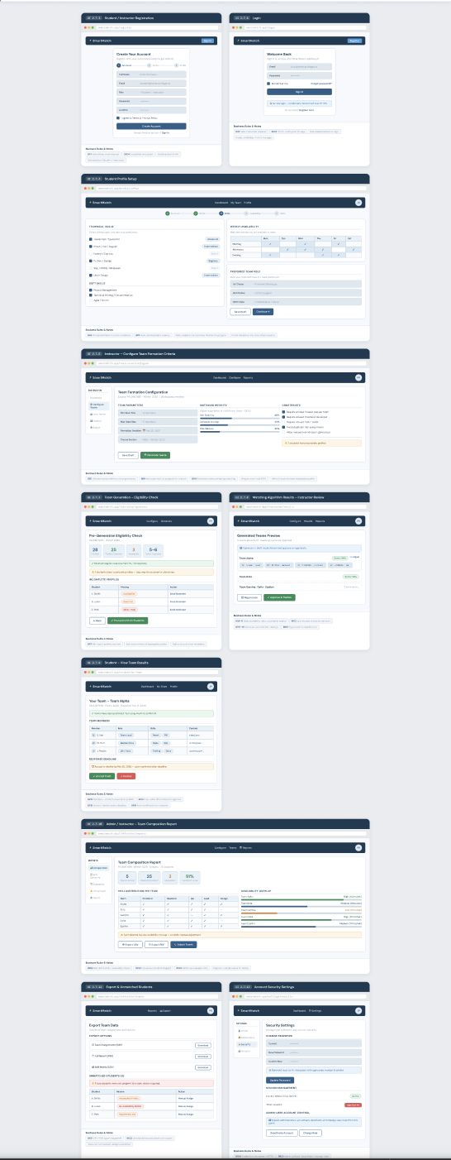

Section 3

3.1 Data Flow Diagrams
Data Flow Diagrams (DFDs) illustrate how data moves through the SmartMatch system. They define the system boundary, identify external entities, and show the transformation of data as it passes through processes and data stores.

3.1.1 DFD Level 0 – Context Diagram
The Context Diagram shows SmartMatch as a single system and illustrates how external entities exchange data with it. It defines the system boundary and the highest-level inputs/outputs.

Purpose
The Context Diagram provides a high-level overview of the SmartMatch system, identifying all external entities that interact with it and the data flows between them. This establishes the system scope and boundary.

External Entities
E1: Student – Registers, logs in, submits profile data, and receives team match results.
E2: Admin / Instructor – Configures matching rules and receives reports/exports.

Process
P0: SmartMatch System – The entire system treated as a single process at this level of abstraction.

Data Flows (Level 0)
The following table summarizes all data flows at the context level:

ID | From | To | Data Flow Name | Data Contents
DF0-1 | Student | SmartMatch System | Registration Request | name, email, password
DF0-2 | SmartMatch System | Student | Registration Confirmation | account status, message
DF0-3 | Student | SmartMatch System | Login Request | email, password
DF0-4 | SmartMatch System | Student | Auth Response | success/fail, session/token
DF0-5 | Student | SmartMatch System | Profile Submission/Update | skills, interests, role, availability
DF0-6 | SmartMatch System | Student | Team Match Results | team ID, members, roles, contact
DF0-7 | Admin | SmartMatch System | Matching Configuration | rules, constraints, weights, deadline
DF0-8 | SmartMatch System | Admin | Reports / Export | team list, unmatched students, summary
Figure 3.1 – DFD Level 0: Context Diagram
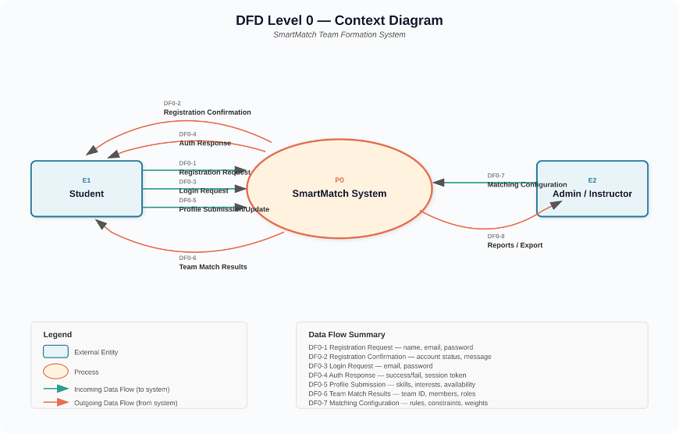

3.1.2 DFD Level 1 – Decomposition
The Level 1 DFD breaks the SmartMatch System into key internal processes and data stores to show how data moves through the system to produce team matches.

Purpose
This diagram decomposes the single P0 process from the Context Diagram into five sub-processes, revealing the internal data movement, storage, and transformation logic of the SmartMatch system.

Processes
P1: User Management – Handles registration, login, and identity/session handling.
P2: Profile Management – Stores and updates student profiles (skills, preferences, availability).
P3: Matching Engine – Applies business rules/constraints to compute compatible groups.
P4: Team Allocation & Publishing – Finalizes teams, stores team records, and publishes results.
P5: Admin Controls & Reporting – Allows configuration of rules and generates exports/reports.

Data Stores
D1: Users DB – Accounts, hashed passwords, roles.
D2: Profiles DB – Skills, interests, availability, preferences.
D3: Matching Rules DB – Constraints, weights, thresholds.
D4: Teams DB – Team ID, members, assigned roles, timestamp.

Data Flows (Level 1)
The following table details all internal data flows:

ID | From | To | Data Flow Name | Notes
DF1-1 | Student | P1 User Management | Registration/Login Data | create session on success
DF1-2 | P1 User Management | D1 Users DB | User Record Write/Read | store + validate credentials
DF1-3 | Student | P2 Profile Management | Profile Data | submit/update profile
DF1-4 | P2 Profile Management | D2 Profiles DB | Profile Write/Read | store profile details
DF1-5 | Admin | P5 Admin Controls | Rule Configuration | set team size, weights, constraints
DF1-6 | P5 Admin Controls | D3 Matching Rules DB | Rules Write/Read | version rules
DF1-7 | P3 Matching Engine | D2 Profiles DB | Profile Retrieval | pull eligible student data
DF1-8 | P3 Matching Engine | D3 Matching Rules DB | Rules Retrieval | apply constraints
DF1-9 | P3 Matching Engine | P4 Team Allocation | Match Candidates | computed grouping output
DF1-10 | P4 Team Allocation | D4 Teams DB | Team Record Write/Read | store finalized teams
DF1-11 | Student | P4 Team Allocation | View Results Request | fetch assigned team
DF1-12 | P4 Team Allocation | Student | Team Match Results | members + roles
DF1-13 | Admin | P5 Admin Controls | Report Request | exports
DF1-14 | P5 Admin Controls | D4 Teams DB | Team Data Retrieval | generate reports
DF1-15 | P5 Admin Controls | Admin | Reports / Export | PDF/CSV summary
Figure 3.2 – DFD Level 1: System Decomposition
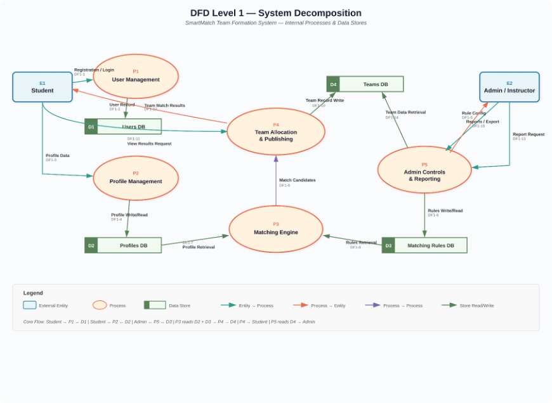

3.2 User Stories and related Use Case Scenarios
Use Case: Seneca Student Registers for App
· Actor: Student
· Precondition:
o The user is a student enrolled in one or more classes at Seneca
o The student knows their Seneca email and password
o The student has device that is compatible with the application
o The student has a stable internet connection
· Main Flow:
1. The user clicks on the sign-up button
2. The system prompts student to type in Seneca email and create a new password that you type in twice
3. The student enters the email and passwords
4. The system checks that passwords match
5. The system checks if email is in database
6. The system checks if the institution is recognized
7. The institution checks if email belongs to a student that is currently enrolled in a class at Seneca and then relays that information to the system
8. The system generates a random verification link and sends it to the student’s Seneca email
9. The student clicks on the verification link in their email
10. The use case ends successfully
· Alternative Flow:
A1: Passwords do not match
o System detects that the passwords do not match
o At step 4, the system displays error message: “Passwords do not match”
o Will continue to display error until student types in matching passwords
A2: Email already belongs to an account
o System detects that the email address the student enters already belongs to an account by cross-referencing email with database
o At step 5, system displays error message: “This email already belongs to an account”
o Proceeds to login use case
A3: Student is not enrolled in

3.3 Activity Diagrams
Login AD
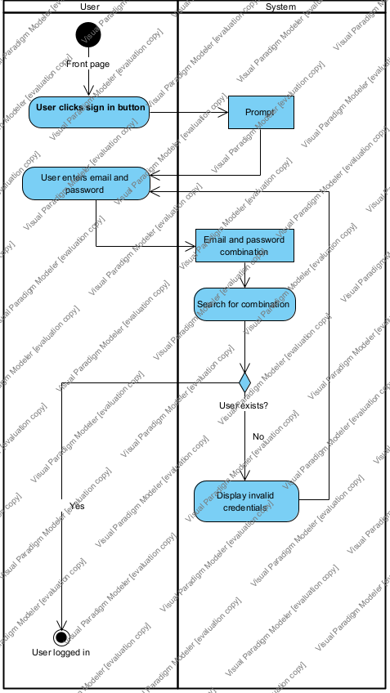
Profile Setup AD
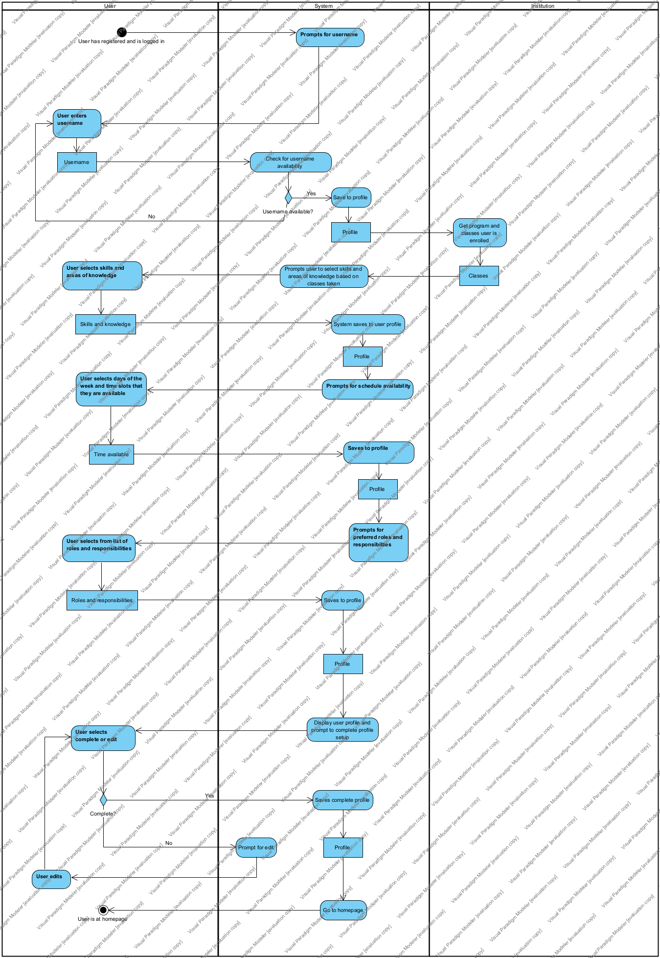
Registration AD
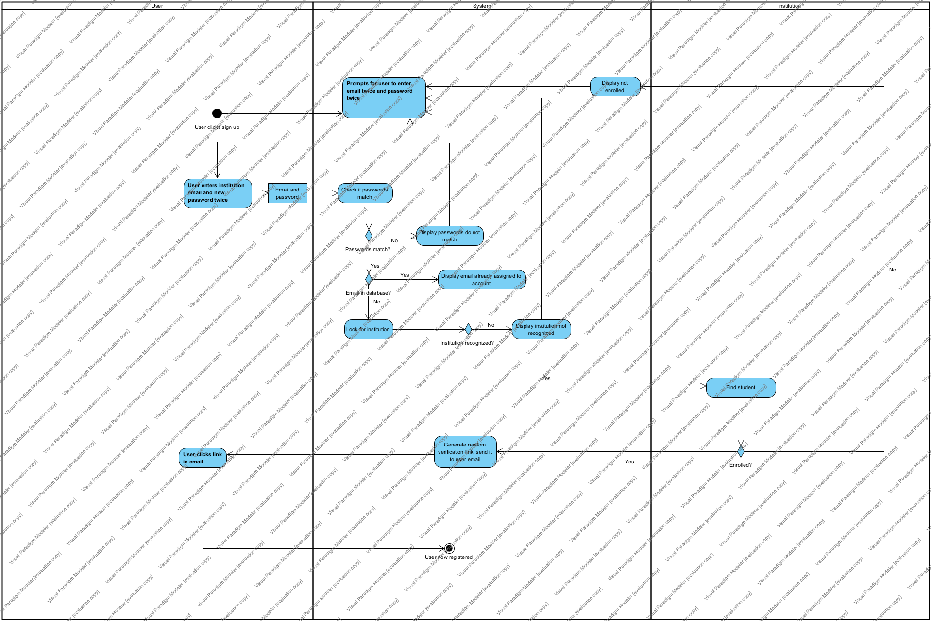
Team Matching Process AD
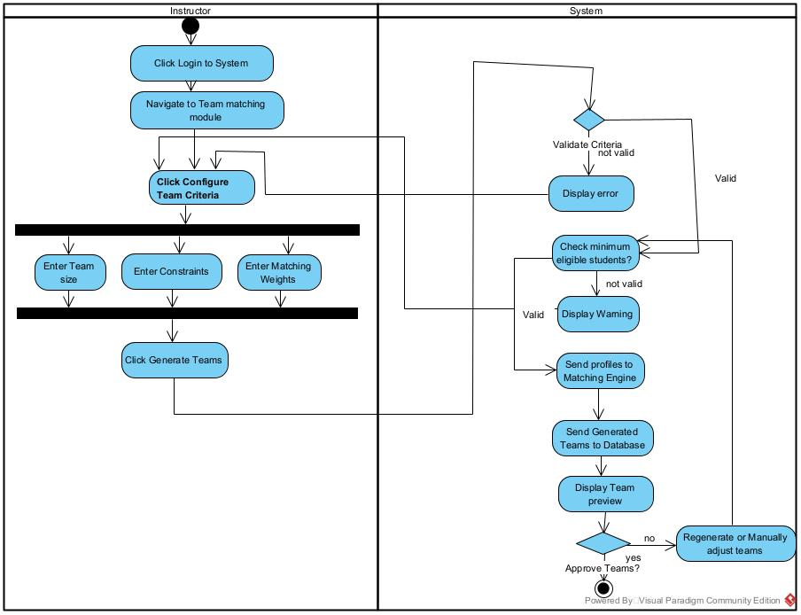
View Team Results AD
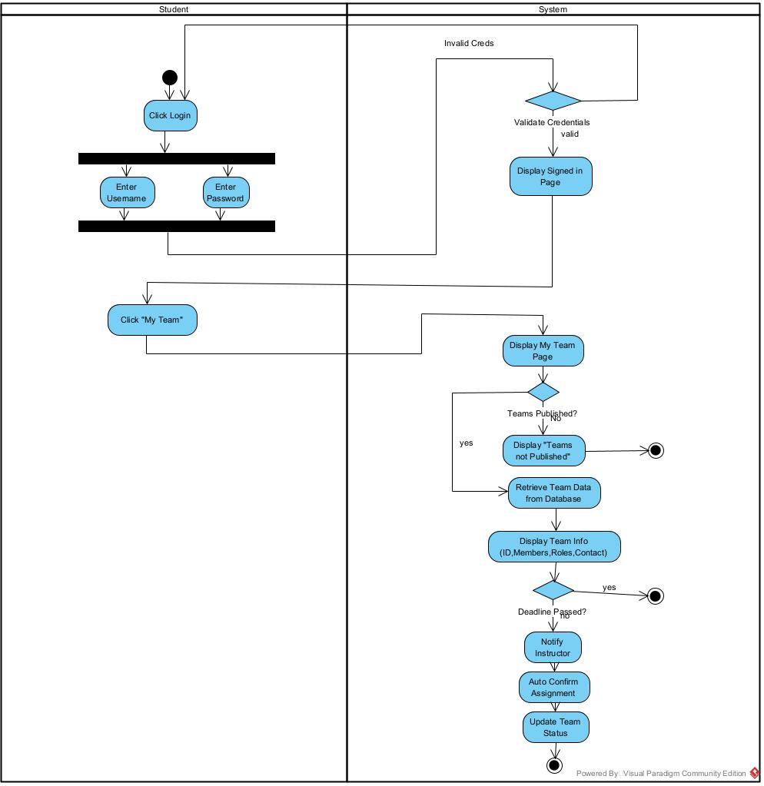

3.4 Business Rules

Business Rule # | Description | Activity Diagram | Related UCS | UI  Mock-up
BR1 | A user must register with a valid institutional email address before accessing the system. | AD1 | UC1 | UI 2.7.2
BR2 | A registered user must authenticate with valid credentials to log in to the system. | AD2 | UC2 | UI 2.7.3
BR3 | A student must complete all required profile fields (skills, availability, role preference) before being eligible for team matching. | AD3 | UC3 | UI 2.7.4
BR4 | A student’s profile data must be validated against predefined formats and constraints before being saved. | AD3 | UC3 | UI 2.7.4
BR5 | An instructor must define team formation criteria (team size, matching weights, constraints) before initiating the matching process. | AD5 | UC4 | UI 2.7.6
BR6 | An instructor must be assigned to at least one course before configuring team formation rules. | AD6 | UC5 | UI 2.7.6
BR7 | The system shall only generate team matches when the minimum number of eligible student profiles has been reached for the course. | AD7 | UC6 | UI 2.7.7
BR8 | The matching algorithm must consider student skills when forming teams to ensure skill diversity. | AD8 | UC7 | UI 2.7.8
BR9 | The matching algorithm must consider student availability to minimize scheduling conflicts within teams. | AD8 | UC7 | UI 2.7.8
BR10 | The matching algorithm must consider student role preferences to balance leadership and contributor roles across teams. | AD8 | UC7 | UI 2.7.8
BR11 | The matching algorithm must respect all instructor-defined constraints (team size, mandatory criteria) during team generation. | AD8 | UC7 | UI 2.7.8
BR12 | Each student shall be assigned to exactly one team per course; duplicate assignments are not permitted. | AD8 | UC7 | UI 2.7.8
BR13 | A student must be able to view their assigned team members and contact information after teams are published. | AD9 | UC8 | UI 2.7.9
BR14 | Team match results shall only be visible to students after the instructor has reviewed and approved the generated teams. | AD9 | UC8 | UI 2.7.9
BR15 | A student may accept or reject a team recommendation within the deadline set by the instructor. | AD9 | UC8 | UI 2.7.9
BR16 | If a student does not respond to a team recommendation before the deadline, the system shall automatically confirm the assignment. | AD9 | UC8 | UI 2.7.9
BR17 | An instructor must be able to review and override team assignments before final publication. | AD10 | AD9 | UI 2.7.9
BR18 | An instructor must be able to regenerate team matches if the initial results are unsatisfactory. | AD10 | AD9 | UI 2.7.9
BR19 | An instructor must be able to manually reassign individual students to different teams after generation. | AD10 | AD9 | UI 2.7.9
BR20 | The system shall generate team composition reports for instructors showing skill distribution, availability overlap, and role allocation. | AD11 | UC10 | UI 2.7.10
BR21 | The system shall allow instructors to export team assignment data in a downloadable format (e.g., CSV or PDF). | AD11 | UC10 | UI 2.7.11
BR22 | The system shall display unmatched students (if any) in the report so the instructor can take corrective action. | AD11 | UC10 | UI 2.7.11
BR23 | A system administrator must be able to manage user accounts, including activation, deactivation, and role assignment. | AD12 | UC11 | UI 2.7.10
BR24 | All user authentication credentials must be stored in encrypted form and transmitted over secure connections. | AD13 | UC12 | UI 2.7.12

Section 4 – Domain Class

Section 5 – Database

Section 6 – Project Management

6.1 Work Breakdown Structure

6.2 Milestones & Acceptance Criteria

Section 7 – Product Backlog & Implementation Schedule

Section 8 – Client/Faculty Sign-off

